• Identify the current USB devices (hint. : lsusb)

• Count how many CPUs (cores) on your device. (hint: /proc/cpuinfo)

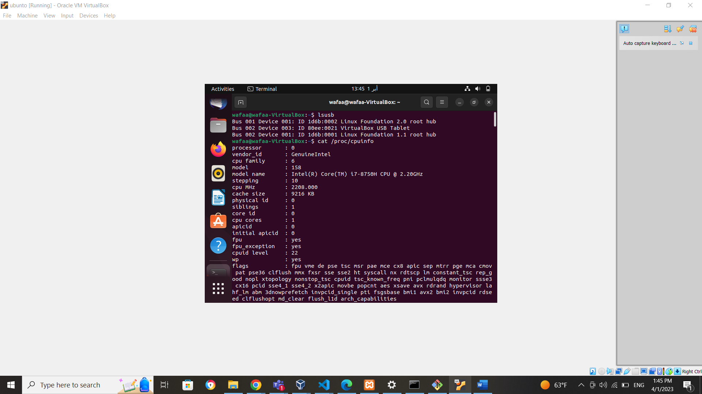

• Take a snapshot of current disk statistics 5 times with 2 seconds interval. (hint: iostat)

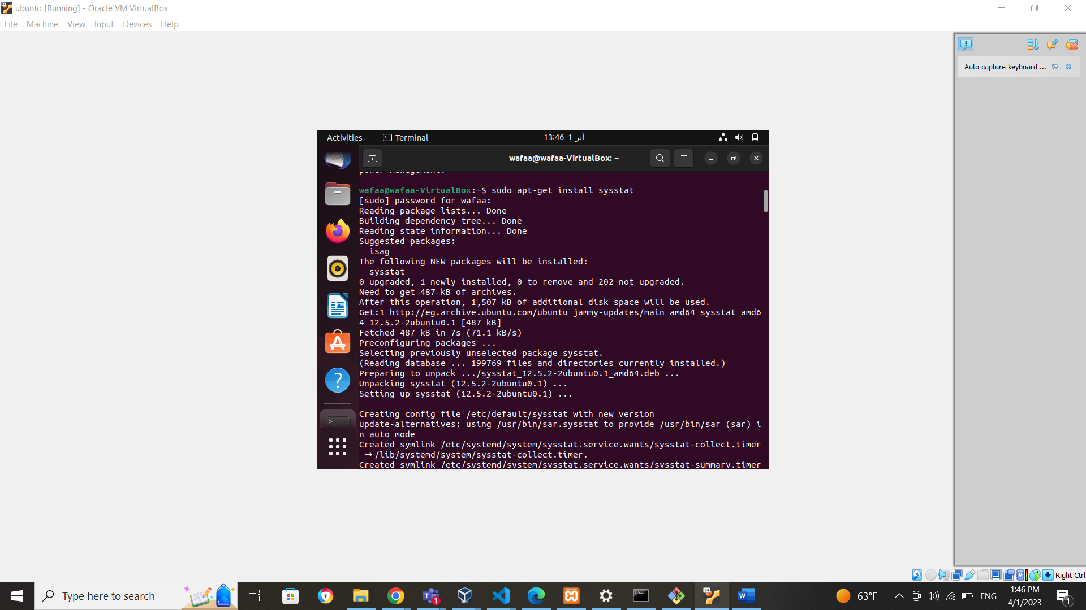

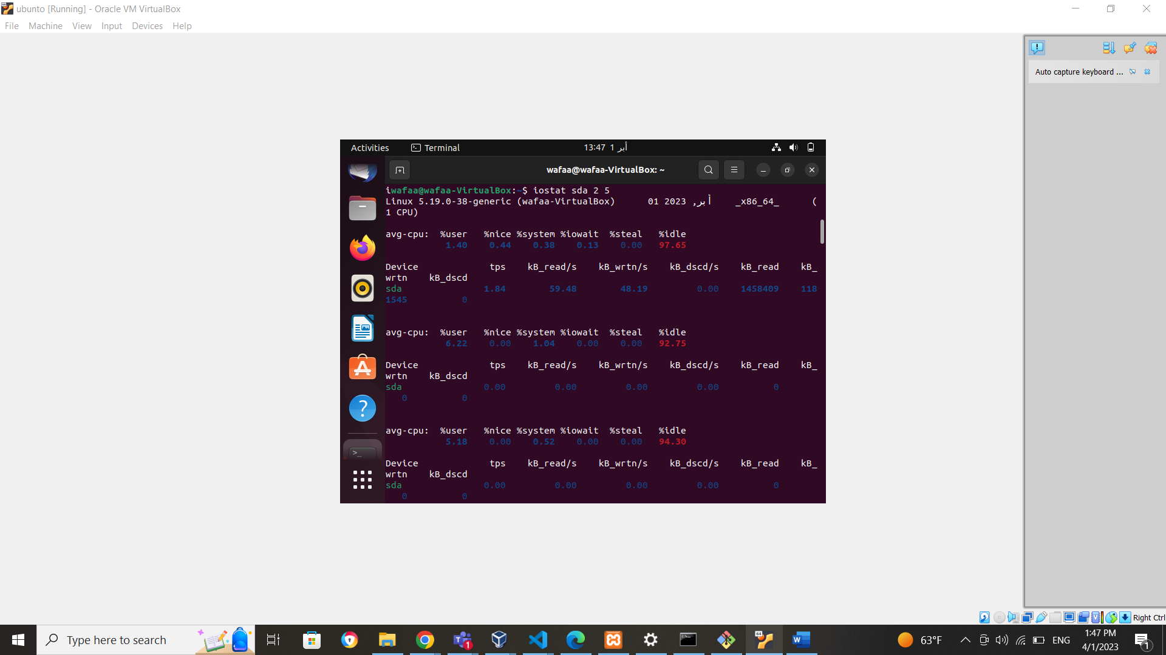

• measure the network activities using (hint: nicstat)

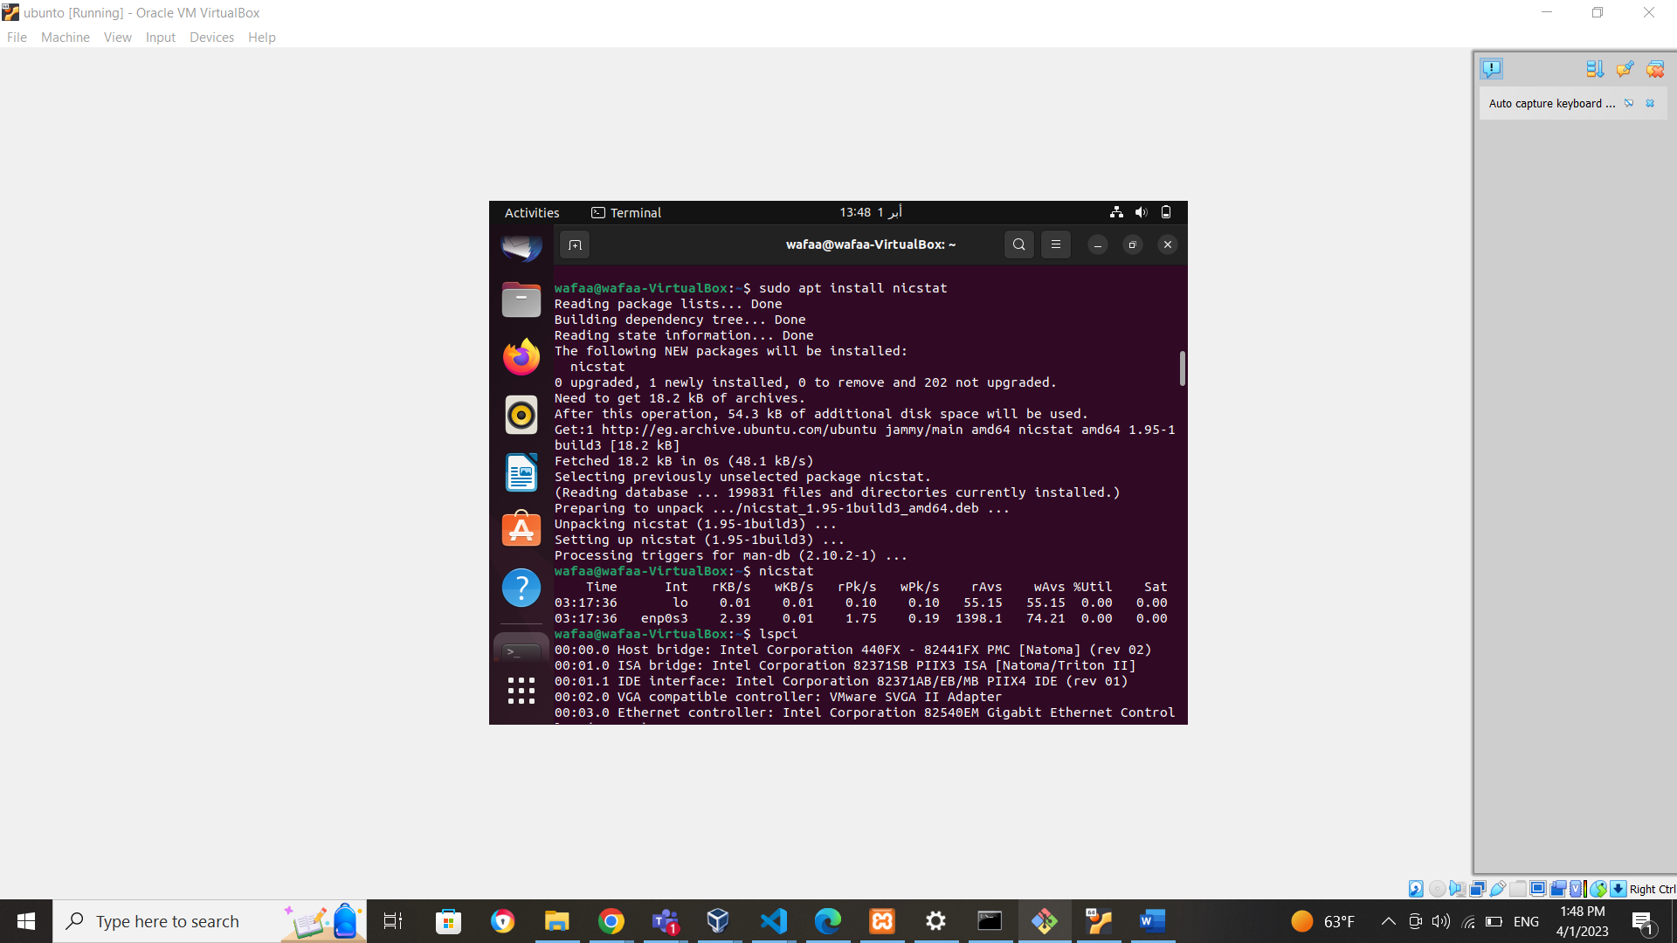

• List current PCI devices on your device (hint: lspci)

• List all files which are compressed by ZIP utilities

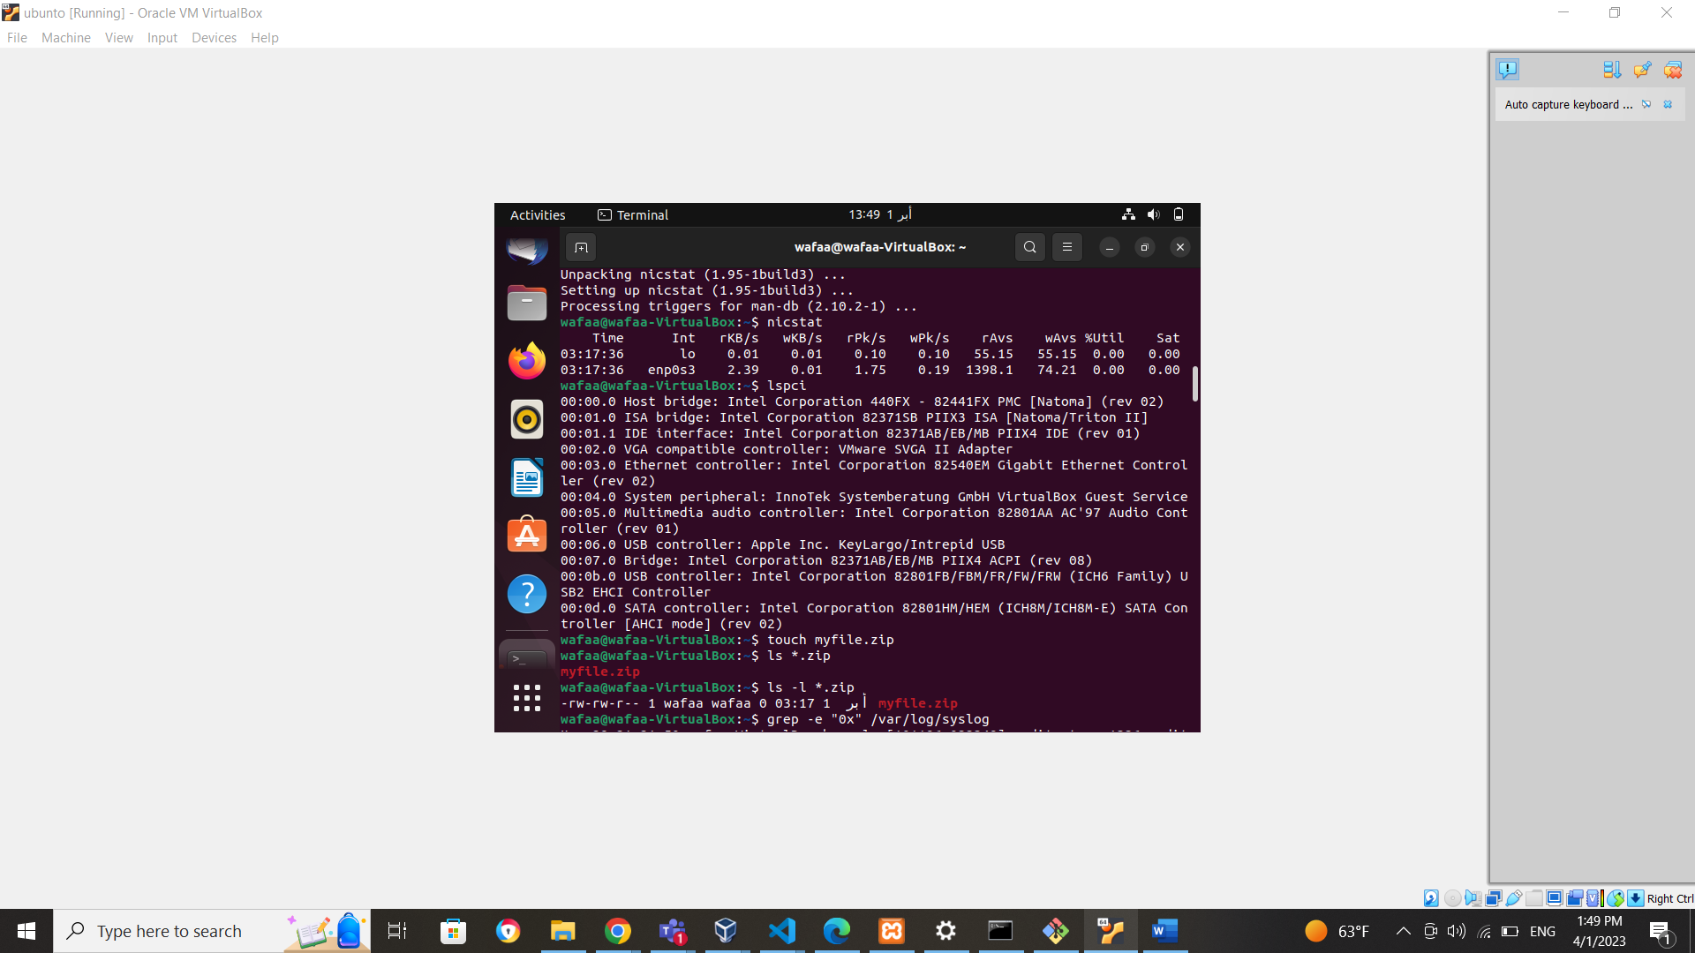

• Using grep and regex list all lines containing hex numbers on a /var/log/syslog

